Certificate of Completion

Congratulations, Rahul B C

Tableau Essential Training (2020.1)

Course completed on April 05, 2025 at 06:24AM UTC • 4 hours 40 min

By continuing to learn, you have expanded your perspective, sharpened your skills, and made yourself even more in demand.

Head of Content Strategy, Learning

LinkedIn Learning 1000 W Maude Ave Sunnyvale, CA 94085

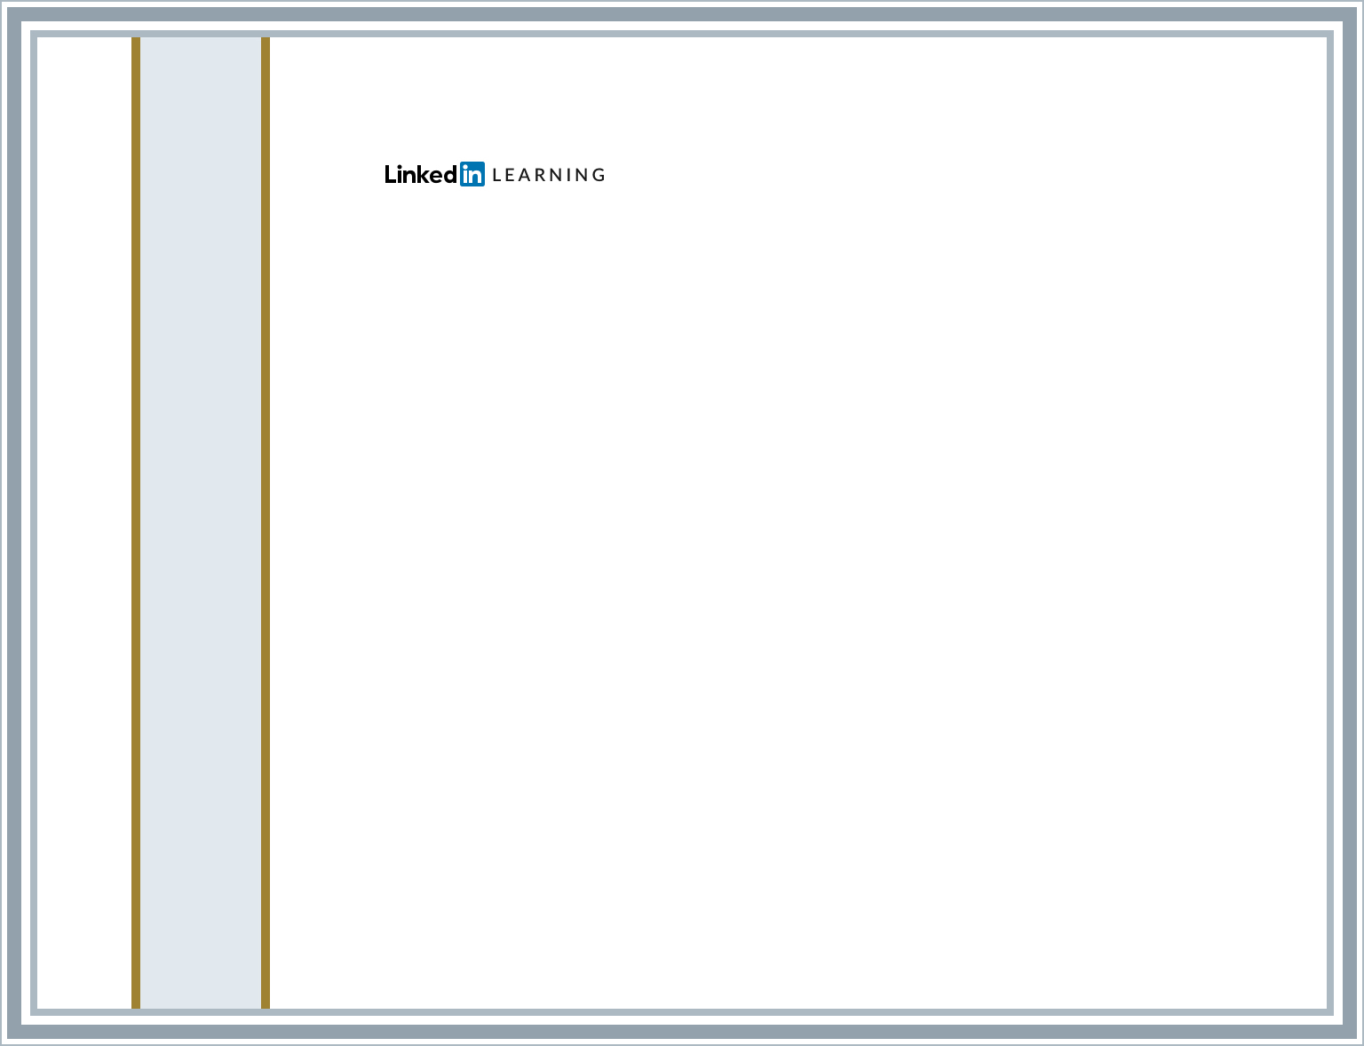

Certificate Id: AYOlThmwV1RgnlBNtDoOqfBF9umh